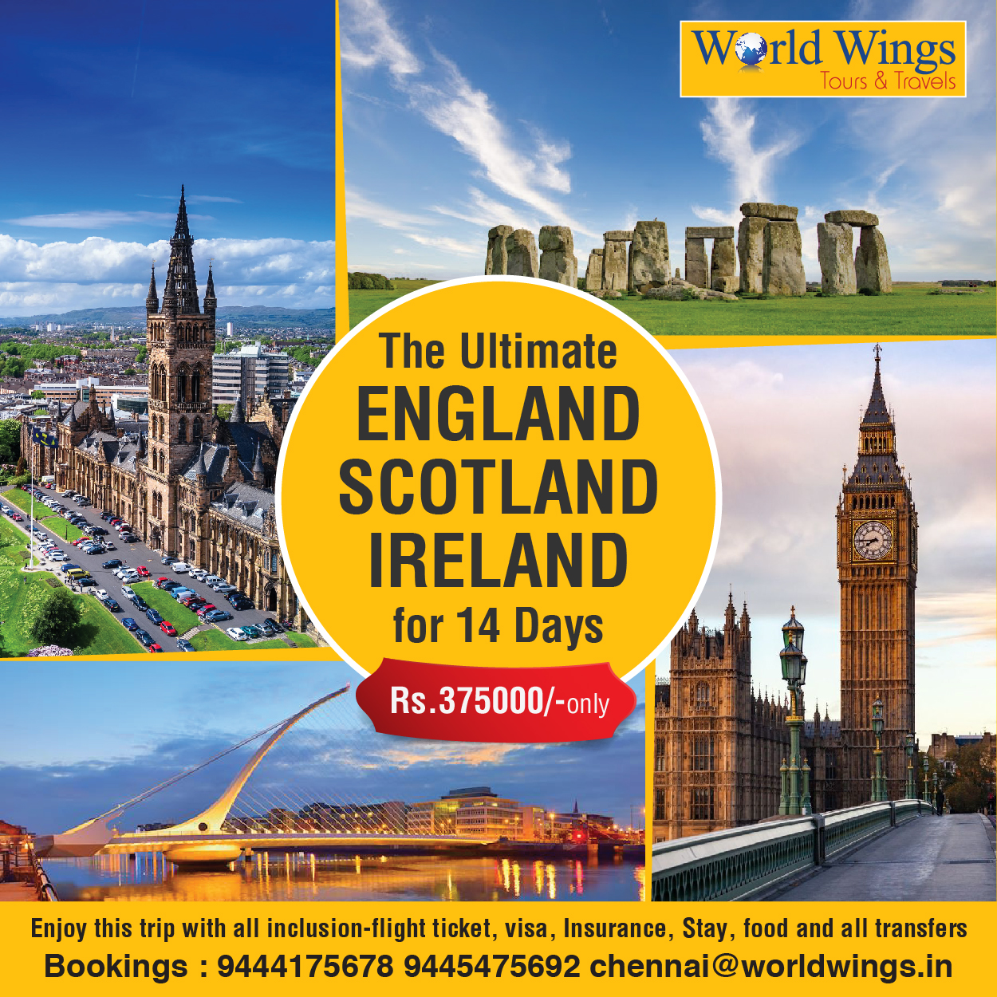

ULTIMATE UNITED KINGDOM PACKAGE
14 DAYS / 13 NIGHTS
ENGLAND – SCOTLAND – IRELAND

Overview:
Experience the best of the United Kingdom covering London, Cardiff, Dublin, Belfast, Glasgow and Edinburgh with scenic landscapes, historic landmarks, and cultural experiences.

Tour Highlights
- Covers 3 countries – England, Scotland & Ireland in one comprehensive itinerary
- London city tour with iconic landmarks & Changing of Guards ceremony
- Visit to Madame Tussauds and Stonehenge
- Scenic ferry journey from UK to Ireland with coach onboard
- Unique Horse Carriage Ride in Killarney National Park
- Experience the Cliffs of Moher & Inis Oirr Island ferry ride
- Guided tours of Bath, Cardiff, Limerick, Galway, Dublin, Belfast, Glasgow & Edinburgh
- Explore Guinness Storehouse Experience in Dublin
- Visit the natural wonder Giant’s Causeway
- Discover maritime history at Titanic Belfast
- Ferry crossing from Ireland to Scotland (Belfast/Larne – Cairnryan)
- Entry to Edinburgh Castle and guided Edinburgh city tour
- Experience Scottish whisky distillery (Glengoyne)
- Enjoy a relaxing Windermere Lake Cruise (Lake District)
- Visit Oxford & Bicester Village shopping outlet
- Comfortable travel with long-distance coach & guided services throughout
- Includes multiple ferry crossings, island visits & scenic countryside drives

Itinerary (Day-wise):
Day 01 : Arrival in London
Arrival at Heathrow Airport. Transfer to hotel and check-in (after 1500 hrs). Dinner at Indian restaurant. Overnight stay.

Day 02 : London City Tour & Madame Tussauds London
Guided city tour covering Big Ben, Buckingham Palace, Tower Bridge and more. Visit Madame Tussauds. Overnight stay.

Day 03 : London – Stonehenge – Bath – Cardiff
Proceed to Stonehenge, continue to Bath for guided city tour, then drive to Cardiff. Overnight stay.

Day 04 : Cardiff – Ferry – Waterford
City tour of Cardiff. Proceed to Fishguard and board ferry to Rosslare. Continue to Waterford. Overnight stay.

Day 05 : Waterford – Killarney – Limerick
Proceed to Killarney and enjoy horse carriage ride at Killarney National Park. Continue to Limerick with guided city tour. Overnight stay.

Day 06 : Limerick – Cliffs of Moher – Galway
Visit Cliffs of Moher. Ferry from Doolin to Inis Oirr Island. Continue to Galway with guided city tour. Overnight stay.

Day 07 : Galway – Dublin
Proceed to Dublin. Guided city tour and visit Guinness Storehouse. Overnight stay.

Day 08 : Dublin – Giant’s Causeway – Belfast
Proceed to Giant’s Causeway. Continue to Belfast. Overnight stay.

Day 09 : Belfast City Tour & Titanic Belfast
Visit Titanic Belfast and enjoy guided city tour. Overnight stay.

Day 10 : Belfast – Ferry – Glasgow
Ferry from Belfast to Cairnryan. Proceed to Glasgow and enjoy guided city tour. Overnight stay.

Day 11 : Glasgow – Edinburgh – Distillery Visit
Proceed to Edinburgh. Guided city tour and visit Edinburgh Castle. Enjoy Glengoyne Distillery. Return to Glasgow. Overnight stay.

Day 12 : Glasgow – Lake District – Manchester
Proceed to Lake District and enjoy Lake Windermere cruise. Continue to Manchester. Overnight stay.

Day 13 : Manchester – Oxford – Bicester Village – London
Proceed to Oxford for guided tour. Free time at Bicester Village. Continue to London. Overnight stay.

Day 14 : Departure from London
Breakfast and transfer to airport. Tour ends.

Cost:4,23,500 per person (All Inclusive)

Trip Cost Breakdown:
- Based on 45 Adults (Double Sharing)
- Cost varies based on travel dates & availability
- Includes hotels, transfers, sightseeing, ferry & entrance tickets

Inclusions:
- 13 Nights accommodation
- Daily breakfast
- 12 Lunch & 13 Dinner
- Private coach & driver
- Ferry transfers (UK–Ireland–Scotland)
- Sightseeing & entrance tickets as per itinerary
- Guided city tours

Exclusions:
- Airfare
- 5% GST & 5% TCS
- Driver tips
- Porterage
- Personal expenses
- Travel insurance
- Any services not mentioned

